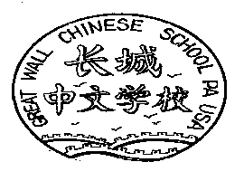Great Wall Chinese School
PMB 128, 2820 Audubon Village Dr., Norristown, PA 19403
http://www.greatwall.org school@greatwall.org

Date

Great Wall Chinese School Volunteer Service Record

Volunteer’s Name __________________________________ Semester/Year_______________
Address: _____________________________________________________________________
Service Date | Hours | Type of Service | Official Initials

Total number of hours volunteered: __________

________________________________________ ____________________________________________

Principal Name (Print) Volunteer Service Coordinator Name (Print)

________________________________________ ____________________________________________

Principal Signature Volunteer Service Coordinator Signature

Date ___________________________________ Date ________________________________________

Great Wall Chinese School is a non-profit organization registered in the state of Pennsylvania, USA. The mission of the school is to cherish Chinese values and heritage, foster and enhance friendship among Chinese and other ethnic communities, contribute to the mutual understanding and appreciation of Chinese and other cultures, and enhance cultural exchange between China and the U.S.

